**Module-1 (SE - Overview of its industry)**

**Q1:** **What is software? what is software engineering?**

**Ans:** Software is a program or set of programs containing instructions that provide desired functionality. Engineering is the process of designing and building something that serves a particular purpose and finds a cost-effective solution to problems.

Software Engineering is the process of designing, developing, testing, and maintaining software. It is a systematic and disciplined approach to software development that aims to create high-quality, reliable, and maintainable software.

**Main Attributes of Software Engineering**

Software Engineering is a systematic, disciplined, quantifiable study and approach to the design, development, operation, and maintenance of a software system. There are four main Attributes of Software Engineering.

**1.Efficiency**: It provides a measure of the resource requirement of a software product efficiently.

**2.Reliability**: It assures that the product will deliver the same results when used in similar working environment.

**3.Reusability**: This attribute makes sure that the module can be used in multiple applications.

**4.Maintainability**: It is the ability of the software to be modified, repaired, or enhanced easily with changing requirements**.**

**Q2:** **Explain types of software?**

**Ans:** In a computer system, the software is basically a set of instructions or commands that tell a computer what to do. In other words, the software is a computer program that provides a set of instructions to execute a user’s commands and tell the computer what to do. For example, like MS-Word, MS-Excel, PowerPoint, etc.

1. **System Software**

**Types of Software**

It is a collection of data that is given to the computer to complete a particular task. The chart below describes the types of software:

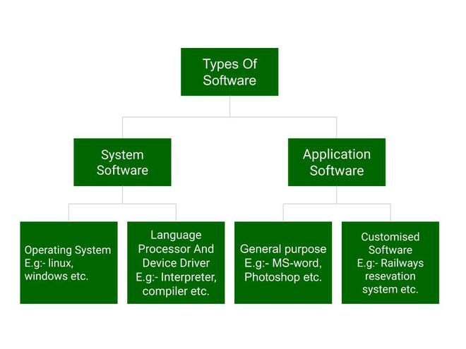

System software is software that directly operates the computer hardware and provides the basic functionality to the users as well as to the other software to operate smoothly.

**Types of System Software**

It has two subtypes which are:

**Operating System**: It is the main program of a computer system. When the computer system ON it is the first software that loads into the computer’s memory. Basically, it manages all the resources such as computer memory, CPU, printer, hard disk, etc.

**Language Processor:** As we know that system software converts the human-readable language into a machine language and vice versa. So, the conversion is done by the language processor. It converts programs written in high-level programming languages like Java, C, C++, Python, etc(known as source code), into sets of instructions that are easily readable by machines(known as object code or machine code).

**Device Driver:** A device driver is a program or software that controls a device and helps that device to perform its functions. Every device like a printer, mouse, modem, etc. needs a driver to connect with the computer system eternally. So, when you connect a new device with your computer system, first you need to install the driver of that device so that your operating system knows how to control or manage that device.

**2.Application Software**

Software that performs special functions or provides functions that are much more than the basic operation of the computer is known as application software. Or in other words, application software is designed to perform a specific task for end-users. It is a product or a program that is designed only to fulfil end-users’ requirements. It includes word processors, spreadsheets, database management, inventory, payroll programs, etc.

**Types of Application Software**

There are different types of application software and those are:

**General Purpose Software:** This type of application software is used for a variety of tasks and it is not limited to performing a specific task only. For example, MS-Word, MS-Excel, PowerPoint, etc.

**Customized Software:** This type of application software is used or designed to perform specific tasks or functions or designed for specific organizations. For example, railway reservation system, airline reservation system, invoice management system, etc.

**Utility Software:** This type of application software is used to support the computer infrastructure. It is designed to analyse, configure, optimize and maintains the system, and take care of its requirements as well. For example, antivirus, disk fragmenter, memory tester, disk repair, disk cleaners, registry cleaners, disk space analyzer, etc.

**Q3:** **What is SDLC? Explain each phase of SDLC?**

**Ans:** The Software Development Life Cycle (SDLC) is a process used by software development organizations to plan, design, develop, test, deploy, and maintain software applications.

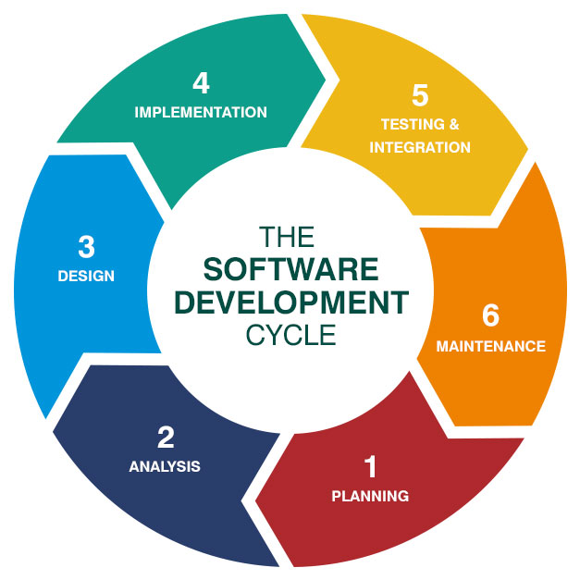

**1. Requirements gathering and analysis:** This phase involves gathering information about the software requirements from stakeholders, such as customers, end-users, and business analysts.

**2. Design:** In this phase, the software design is created, which includes the overall architecture of the software, data structures, and interfaces. It has two steps:

**High-level design (HLD):** It gives the architecture of software products.

**Low-level design (LLD):** It describes how each and every feature in the product should work and every component.

**3. Implementation or coding:** The design is then implemented in code, usually in several iterations, and this phase is also called as Development.

**things you need to know about this phase:**

This is the longest phase in SDLC model.

This phase consists of Front end + Middleware + Back-end.

In front-end: Development of coding is done even SEO settings are done.

In Middleware: They connect both the front end and back end.

In the back-end: A database is created.

**4. Testing:** The software is thoroughly tested to ensure that it meets the requirements and works correctly.

**5. Deployment:** After successful testing, the software is deployed to a production environment and made available to end-users.

**6. Maintenance:** This phase includes ongoing support, bug fixes, and updates to the software.

**Q4:** **What is DFD? Create a DFD diagram on Flipkart**

**Ans:** Data Flow Diagram (DFD) represents the flow of data within information systems. Data Flow Diagrams (DFD) provide a graphical representation of the data flow of a system that can be understood by both technical and non-technical users. The models enable software engineers, customers, and users to work together effectively during the analysis and specification of requirements.

Data Flow Diagram can be represented in several ways. The Data Flow Diagram (DFD) belongs to structured-analysis modelling tools. Data Flow diagrams are very popular because they help us to visualize the major steps and data involved in software-system processes.

**Levels of Data Flow Diagram (DFD)**

**0-level DFD**

It is also known as a context diagram. It’s designed to be an abstraction view, showing the system as a single process with its relationship to external entities. It represents the entire system as a single bubble with input and output data indicated by incoming/outgoing arrows.

**1-Level DFD**

This level provides a more detailed view of the system by breaking down the major processes identified in the level 0 DFD into sub-processes. Each sub-process is depicted as a separate process on the level 1 DFD. The data flows and data stores associated with each sub-process are also shown. In 1-level DFD, the context diagram is decomposed into multiple bubbles/processes. In thislevel, we highlight the main functions of the system and breakdown the high-level process of 0-level DFD into subprocesses.

**2-level DFD**

This level provides an even more detailed view of the system by breaking down the sub-processes identified in the level 1 DFD into further sub-processes. Each sub-process is depicted as a separate process on the level 2 DFD. The data flows and data stores associated with each sub-process are also shown.

**DFD diagram on Flipkart**

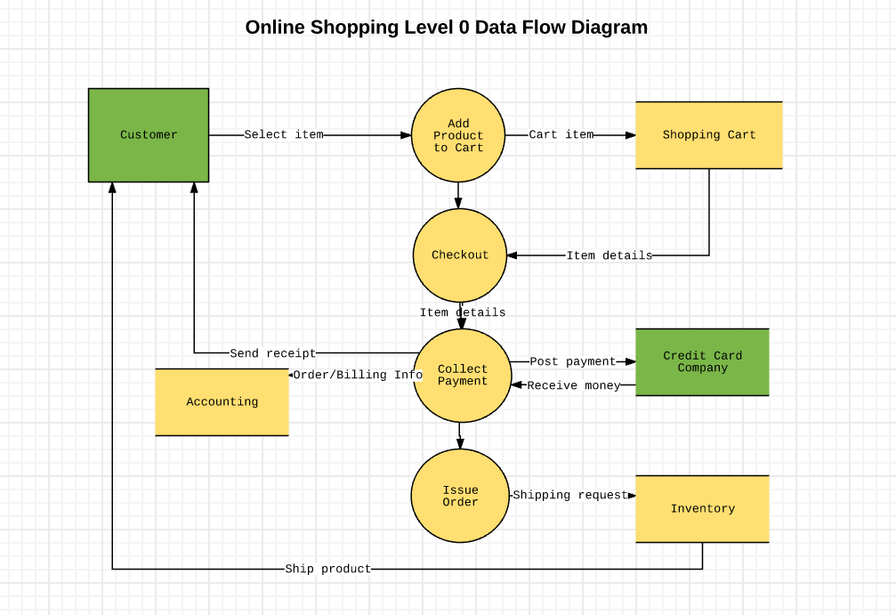

**Q5:** **What is Flow chart? Create a flowchart to make addition of two numbers.**

**Ans:** A flowchart is a type of diagram that represents a workflow or process. A flowchart can also be defined as a diagrammatic representation of an algorithm, a step-by-step approach to solving a task.

Different types of boxes are used to make flowcharts flowchart Symbols. All the different kinds of boxes are connected by arrow lines. Arrow lines are used to display the flow of control. Let’s learn about each box in detail.

|  |  |
| --- | --- |
| **Symbol Name** | **Symbol Representation** |
| **Terminal/Terminator** |  |
| **Process** |  |
| **Decision** |  |
| **Document Symbol** |  |
| **input/output symbol** |  |
| **Stored Data** |  |
| **Flow Arrow** |  |
| **Comment or Annotation** |  |
| **Predefined process** |  |
| **On-page connector/reference** |  |
| **Off-page connector/reference** |  |

**Flowchart to addition of two numbers**

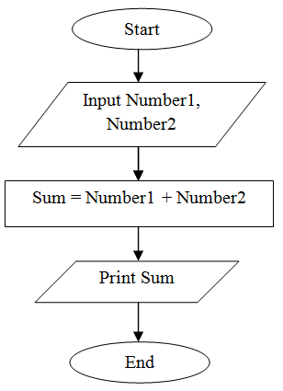

**Q6:** **What is Use case Diagram? Create a use-case on bill payment on PAYTM.**

**Ans:** A Use Case Diagram is a type of Unified Modeling Language (UML) diagram that represents the interaction between actors (users or external systems) and a system under consideration to accomplish specific goals. It provides a high-level view of the system’s functionality by illustrating the various ways users can interact with it.

UML notations provide a visual language that enables software developers, designers, and other stakeholders to communicate and document system designs, architectures, and behaviours in a consistent and understandable manner.

**use-case on bill payment on PAYTM.**

